environment
Jenkins verver: 192.168.145.78:8080
PG client server: 192.168.145.12
PG Server: 192.168.145.30
Git Server:192.168.145.78:3000

implementation process
- upload sql scripts to GIT
- Database Connectivity testing
- transfer sql scritps to PG client server
- set read sql file permission for postgres OS account
- execute sql file

SQL file normally release test

upload scripts to GIT
Create some tables and indexes in three databases (test_db1,test_db2,test_db3),details see below:

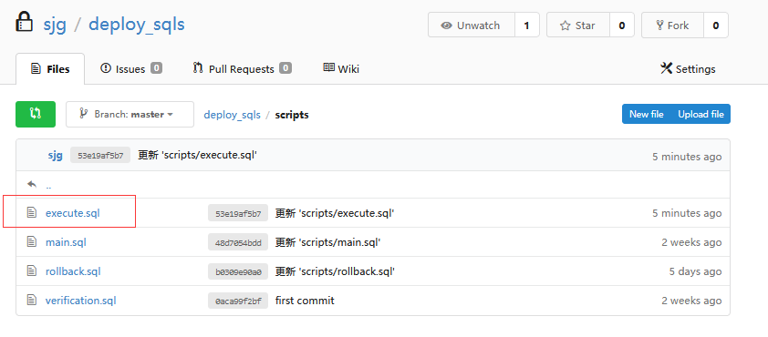

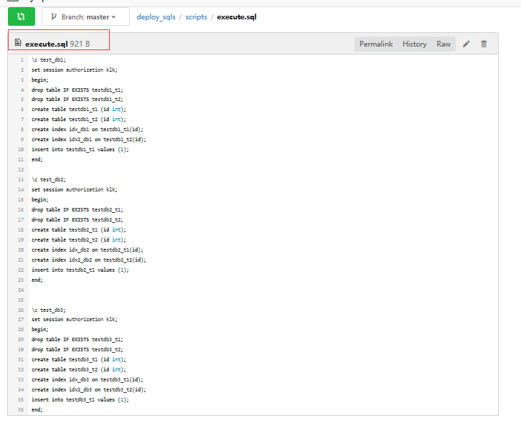

run jenkins pipline
Run pipline job to achieve the following tasks

- Database Connectivity testing
- transfer sql scritps to PG client server
- set read sql file permission for postgres OS account
- execute sql file

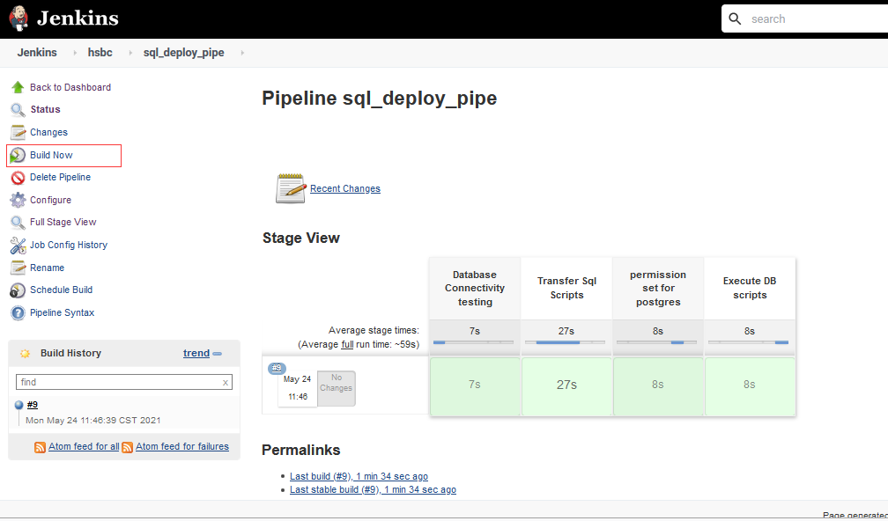

succeed:
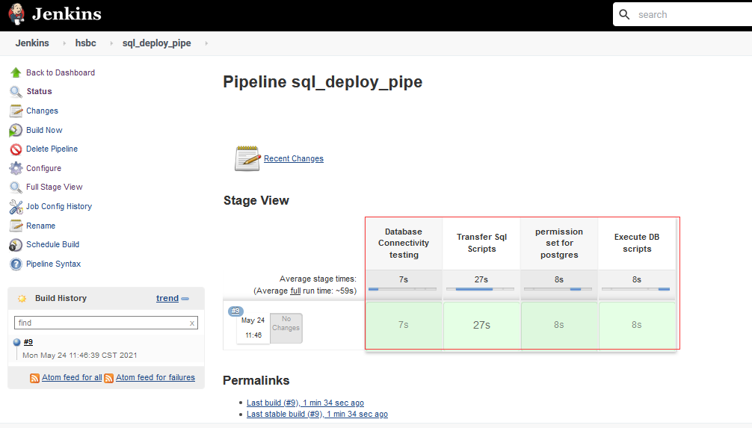

SQL file abnormally release test

upload scripts to GIT
sql error in the second database.
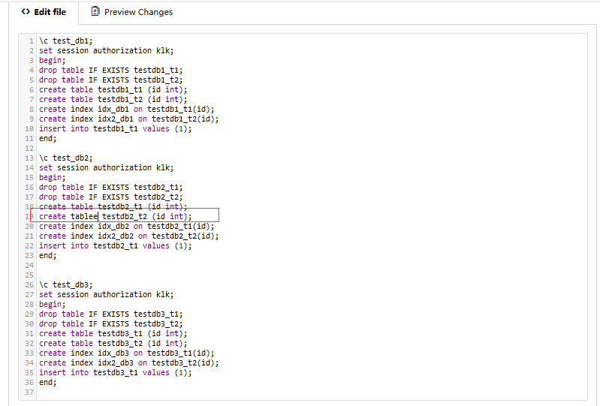

run jenkins pipline
Issue occur in "Execute DB scripts" stage.
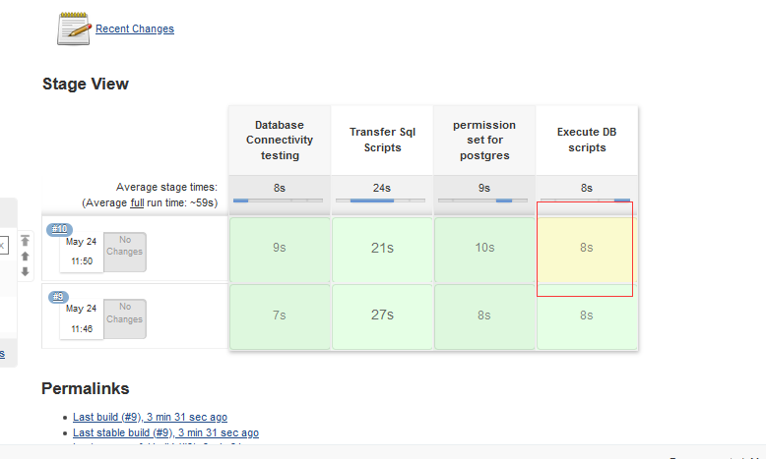
LOG:
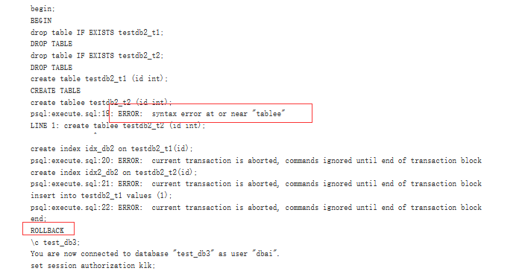

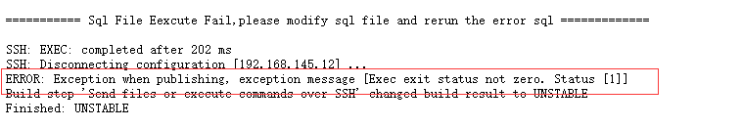

Amend
Sql in database db_test2 rollback,while sql in db_test1,db_test3 commit successfully,need to rerun sqls in db_test2.

update scripts in GIT:

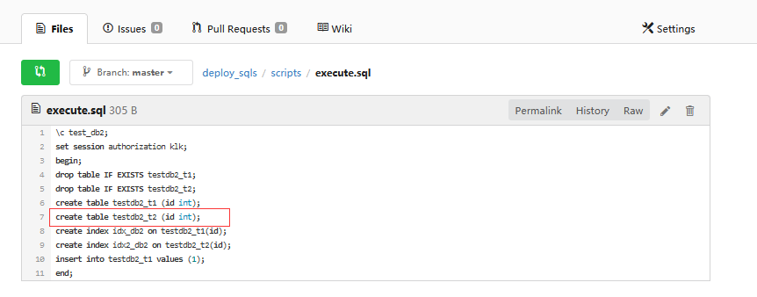
rerun pipeline job:

succeed:
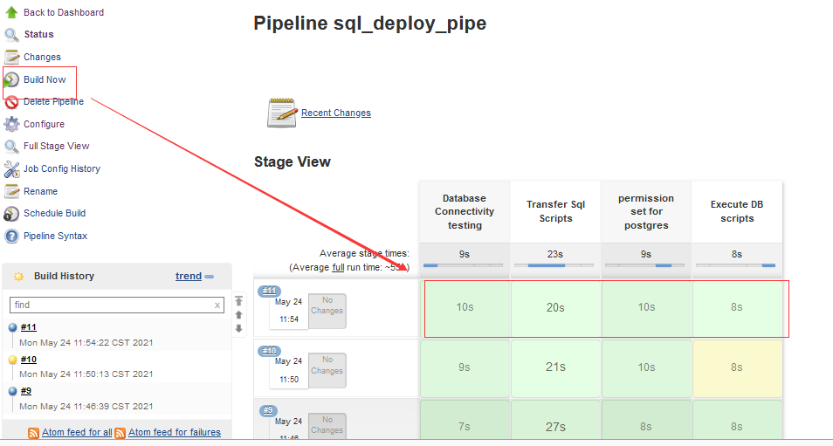

Rollback function
- Application team need to prepare scripts for rollback：

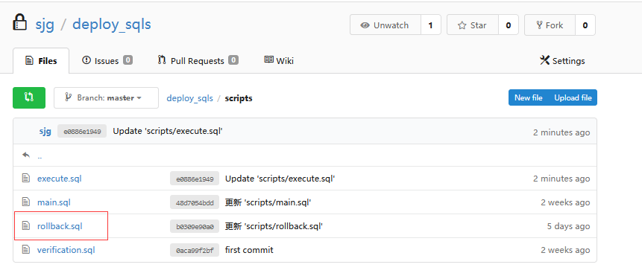
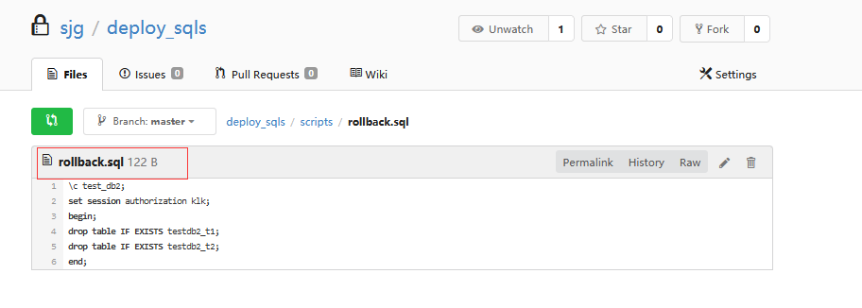

- Run the Jenkins pipeline used to rollback scripts
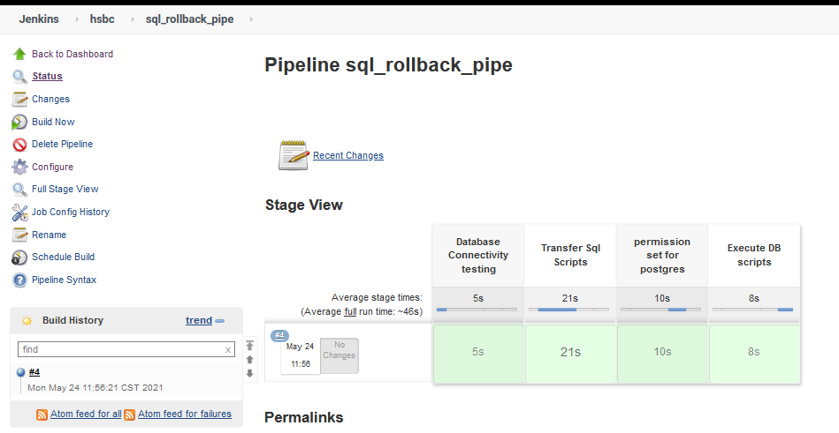

LOGS:
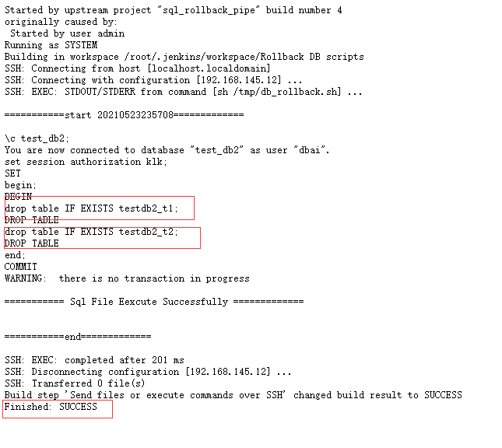

Permission control
By default, any user can have all permissions on a project, as shown below：
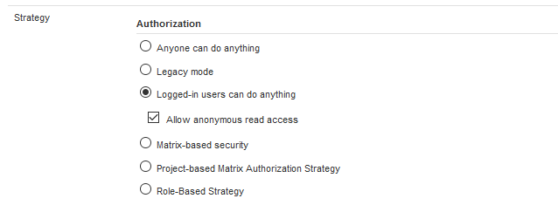

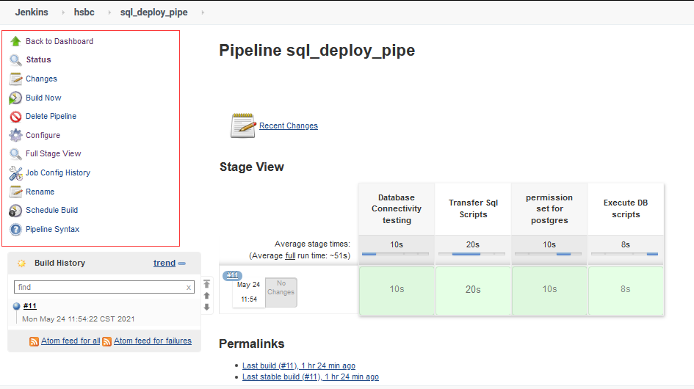

It is recommended to set the permission policy based on project authorization, and the user does not have permission to any project by default unless the relevant permissions are set .
As shown below：
Set read permissions globally for user2：
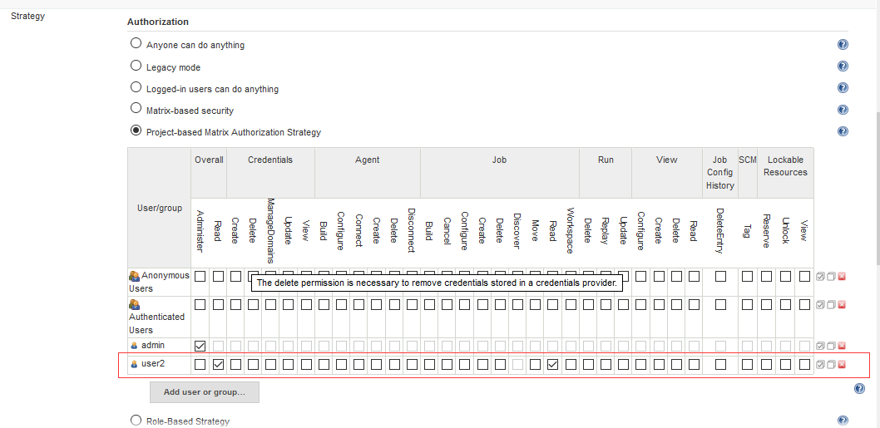

If there is no additional authorization for specific project, the user has only read permission,which is granted in the last step:

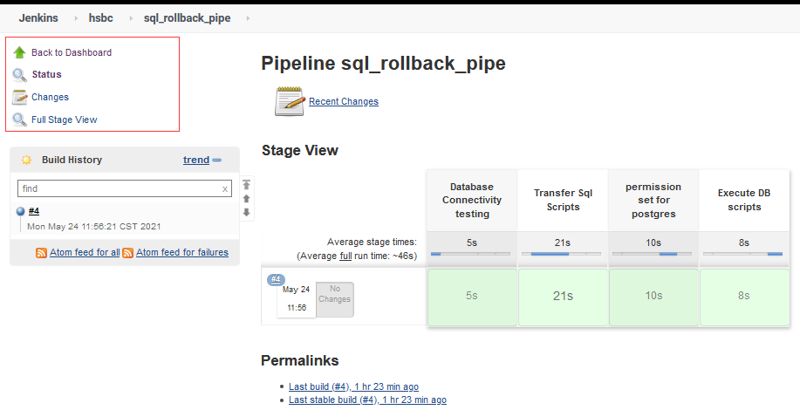

For SQL_ deploy_ Pipe project, set read, build and cancel permissions for user2 :
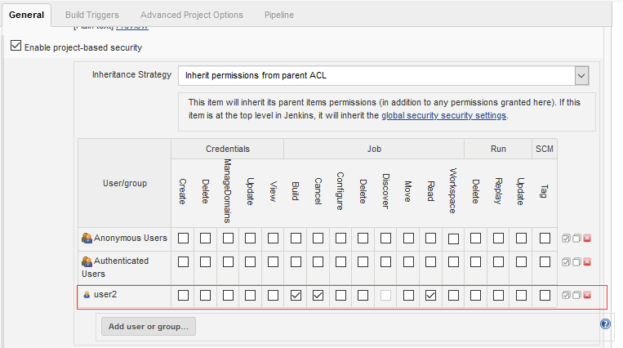

Then user2 can only perform related actions :
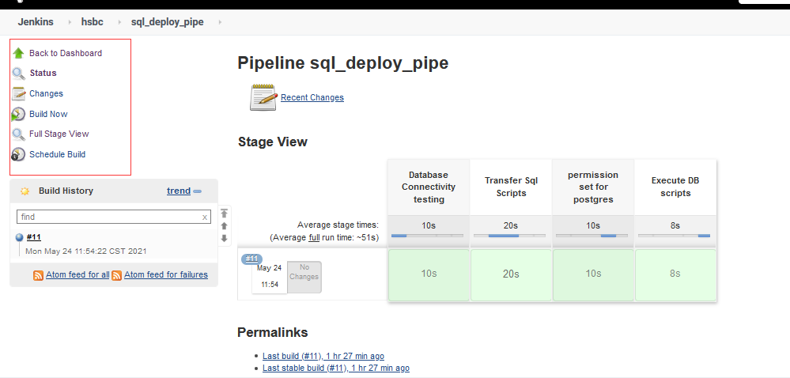

Adding stage for approve
Here I find a way is to add an input instruction in the stage. The program needs to wait for the consent instruction to continue. By controlling which user can consent to the instruction, the specific user can allow the program to continue to run or not.

Key configuration：
stages {
stage('Waiting for approve') {
input {
message "Will you approve?"
ok "approve"
submitter "admin,user1"
}
steps {
echo "Hello, Thanks for approve"
}
}
#only user1 & admin can continue the program.

Testing :

someone running a pipeline job ,but pause for approve:
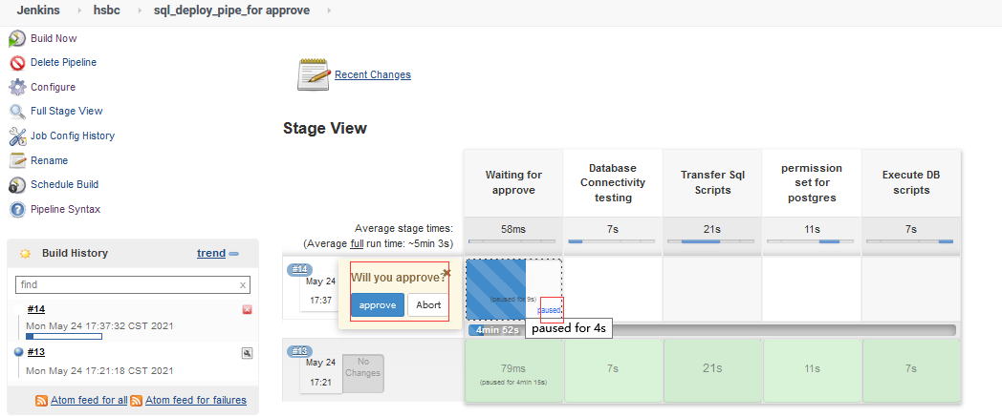

User2 logged in and tried to approve, but it didn't make any difference
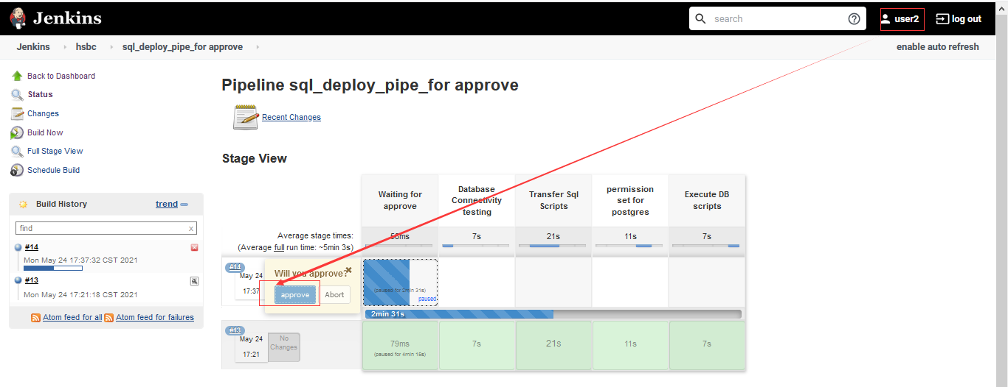
User1 logged in and approved, succeed:
